ICT394 Business Intelligence Application Development

# Lab 03: Measures and Calculations

This lab introduces you to the **creation of both measures** and **calculated columns** to add depth to the supplied data.

**Please note that you may need to answer some questions based on the outcomes of the lab.**

**Version 1.0:** 14th March 2016

Updated: 12th March 2017

**Version 2.0:** 28th August 2017

Updated: 9th March 2018

Updated: 6th March 2019

Updated: 6th February 2021

**Latest update:** 16th September 2022

## Aims:

At the completion of this lab you should be able to:

* Create a **simple measure**
* Create a **calculated column**
* Use the **slicer tool** in Power BI Desktop
* Explain, using an example, when and why a measure or a calculated column would be used

### For this lab, you will need:

Power BI Desktop installed

* + It is a free download, so my suggestion is that all students should try to download and install it on their machines themselves.
  + NB: there is no MAC or Unix version
  + There are a number of installation guides for Power BI Desktop, see: <https://www.microsoft.com/en-us/download/details.aspx?id=45331>

### Dataset:

* **Download the data from** <http://download.microsoft.com/download/4/6/A/46AB5E74-50F6-4761-8EDB-5AE077FD603C/Contoso%20Sales%20Sample%20for%20Power%20BI%20Desktop.zip>
* **Or Download from LMS**: There is also a backup of the data on LMS
* You will have to unzip the file which will leave you with a .pbix file. You will then open that file directly in Power BI Desktop using the File_Open command.

### Create Measures

* **Follow the instructions at** <https://powerbi.microsoft.com/en-us/documentation/powerbi-desktop-tutorial-create-measures/> to **create** the **following measures**:
  + Net Sales
  + Net Sales per Unit

**Useful Hints**:

* 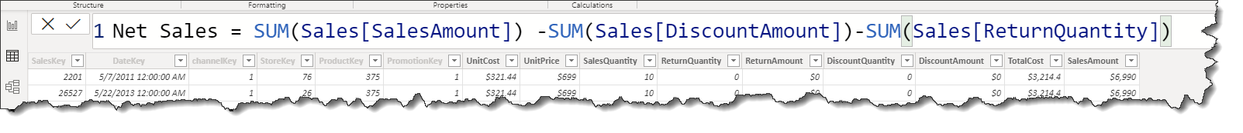To zoom into the formula, select CTRL + Mouse Scroll UP
* Separate parts of your formula by pressing **Alt + Enter** for separate lines, or pressing Tab to add tab spacing.

**QUIZ ALERT:** You should also make sure you keep the page you created because **you will be asked for a value or values** from it in the quiz.

### Create Calculated Columns

This exercise will use the same .pbix file you had from the exercise above.

**Do this exercise on a new page:**

* Create a **new Page**

**Follow the instructions at:** <https://powerbi.microsoft.com/en-us/documentation/powerbi-desktop-tutorial-create-calculated-columns/>

* Create the **Product Full Category** calculated column
* Create the **Active Store Name** calculated column

When you’ve done this, create the visualization “SalesAmount by ActiveStoreName” that is shown at the end of the exercise – shown below.

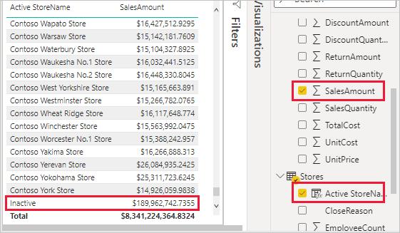

## For this week’s quiz!

You will also be asked in the quiz for one or more values from the charts you created in the first exercise. As such, you should complete the quiz on a machine that has Power BI Desktop installed and running with your .pbix.

## Challenge Task

This week’s challenge task will require you to bring together the things you learnt in this lab. I need to know **which country has the highest net sales per employee**. I also want to be able to quickly see what the values are for any given country. How you present this is up to you.

ENJOY!

## If you are interested

If you want to learn more about DAX, see: <https://powerbi.microsoft.com/en-us/documentation/powerbi-desktop-quickstart-learn-dax-basics/>